**POTÊNCIOMETRO / LED / BUZZER**

**Aluno: Webster Santos**

**RA: 169086**

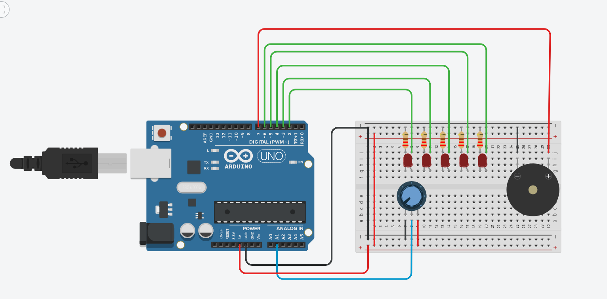

// C++ code

//

int pot = A1;

int led1 = 2;

int led2 = 3;

int led3 = 4;

int led4 = 5;

int led5 = 6;

int buzzer = 7;

void setup()

{

pinMode(pot, INPUT);

pinMode(led1, OUTPUT);

pinMode(led2, OUTPUT);

pinMode(led3, OUTPUT);

pinMode(led4, OUTPUT);

pinMode(led5, OUTPUT);

pinMode(buzzer, OUTPUT);

Serial.begin(9600);

}

void loop()

{

int valor_pot = analogRead(pot);

Serial.println(valor_pot);

if (valor_pot<170)

{

digitalWrite(led1, LOW);

digitalWrite(led2, LOW);

digitalWrite(led3, LOW);

digitalWrite(led4, LOW);

digitalWrite(led5, LOW);

digitalWrite(buzzer, LOW);

}

else if (valor_pot>170 && valor_pot < 341)

{

digitalWrite(led1, HIGH);

digitalWrite(buzzer, LOW);

}

else if (valor_pot > 341 && valor_pot<512)

{

digitalWrite(led1, HIGH);

digitalWrite(led2, HIGH);

digitalWrite(buzzer, LOW);

}

else if (valor_pot>512 && valor_pot<682)

{ digitalWrite(led1, HIGH);

digitalWrite(led2, HIGH);

digitalWrite(led3, HIGH);

digitalWrite(buzzer, LOW);

}

else if (valor_pot>682 && valor_pot<853)

{ digitalWrite(led1, HIGH);

digitalWrite(led2, HIGH);

digitalWrite(led3, HIGH);

digitalWrite(led4, HIGH);

digitalWrite(buzzer, LOW);

}

else

{ digitalWrite(led1, HIGH);

digitalWrite(led2, HIGH);

digitalWrite(led3, HIGH);

digitalWrite(led4, HIGH);

digitalWrite(led5, HIGH);

digitalWrite(buzzer, HIGH);

delay(50);

digitalWrite(led1, LOW);

digitalWrite(led2, LOW);

digitalWrite(led3, LOW);

digitalWrite(led4, LOW);

digitalWrite(led5, LOW);

digitalWrite(buzzer, LOW);

delay(50);

}

}